86.04.02
From John Thurston
RB MSS M76, Library, Royal Botanic Gardens Melbourne.

Government House
Fiji
2nd April 1886
My dear Sir.
In one of our late papers I observed the copy of a letter dated the 28 Nov. last addressed by you to Mr W. K. Thomson of Melbourne with respect to a disease which has recently attacked the Bananas of this Colony.
From the description of the disease it appears to you similar to that recently investigated by Dr Joseph Bancroft of Brisbane when a minute parasite attacks the roots of the plants.
I am inclined to think the 'disease' has not been well described to you and, if you will permit I will now attempt to do so in the hope that your high scientific attainments always so freely and beneficially placed at the public service, may lead to the discovery of the causes of disease and to the means of avoidance.
In the first instance I may state that the disease is not new. I observed very rare instances of it years ago but merely regarded the matter as one of abnormal growth such as may at times be noticed in plants of any genus.
About two years ago the disease became suddenly common among Chinese Bananas. The short sweet M. Cavendishii of which such quantities are expected.
The more robust Musa, the indigenous plantain remained unaffected.
These latter are now shewing signs of disease. The disease is quite unknown to natives.
Its commencement was so general among the islands of Central Fiji, where Bananas are chiefly grown, that I at first (& perhaps still) attributed it to climatic causes.
It seems improbable that minute insects could have contemporaneously, and for the first time appeared in numerous islands separated by wide spaces of sea.
I should in common parlance describe the disease as one of "Strangulation" A diseased plant has the following appearance —
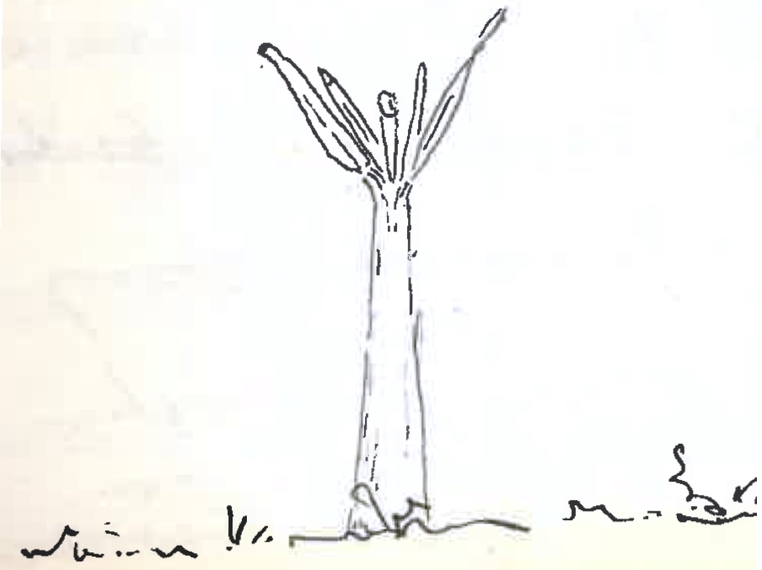

Neither the stem nor the leaves are discoloured. It is merely their size and shape that is altered. The stem is usually of normal size. The leaves narrow, acuminated, harsh (comparatively) in texture and, in time the new leaf rising from the centre is either too weak to ascend or the shoot of the plant is constricted and the perhaps already weakened young leaf cannot force through.
Against both these theories I must add (1) that on cutting transversely through the "throat" or below it I have been unable to detect any lesion of the cells — no tension but what in the ordinary growth of plants would be burst through easily
(2) In the living plant I have passed my Knife longitudinally down the stem splitting the 1, 2, & 3 leaf sheath & so easing the central ones.
No effect whatever.
I attributed it also to over planting in the one area, but I find new plants in new areas are equally attacked. I observe it in old and neglected plantation, in plants 'gone wild' as well as those in cultivation
I can trace no minute insect about the roots.
Can it be the effect of abnormal seasons, unusual & prolonged drought, followed by unusually heavy cold rain?
This theory does not satisfy me.
As you have no bananas in Victoria, and as I do not believe that 'insects' are at the root of the trouble I have sent you four small Banana plants for inspection.
If you can advise me on the subject at your convenience I shall be greatly indebted to you.
Believe me
my dear Sir
Yours very faithfully
John B Thurston

Baron F. Von Mueller KCMG
&c. &c.

Musa Cavendishii

Letter not found.
'Bunchy top' disease, recognised as widespread in Fiji by the early 1890s?
A sketch is inserted here: 86-04-02_image01.jpg

